Software Testing Report

<Victoria State Accident>

Eddie Thompson s5282264

Fletcher Bradley s5292215

Kei Giliam s5270448

Assignment Groups 130

Table of Contents

1.0 Unit Tests 3

2.0 Coverage Report 4

3.0 Requirements Acceptance Testing 5

# Unit Tests

Delete the RED text and replace with your own

(In this table you fill out details about what unit tests you have done using the unittest module)

| **No** | **Test Case** | **Expected Results** | **Actual Results** |
| --- | --- | --- | --- |
| **1.0** | **File reading** |  |  |
| 1.1 | Test the loaded file | Exception Handled | Passed |
| 1.2 | Test adding variables to the data | Passed | Passed |
| **2.0** | **wxFormBuilder** |  |  |
| 2.1 | Test Connecting the program to the GUI | Display error message and exit | Empty Suite |
| 2.2 | Test Adding the data | Display error message and exit | Display error message and exit |
| 2.3 | Test the alcohol button | Display error message and exit | Display error message and exit |
| 2.4 | Test the day filter button | Display error message and exit | Display error message and exit |
| 2.5 | Test clearing the grid | Display error message and exit | Display error message and exit |
| 2.6 | Test the display of the filtered data | Passed | Display error message and exit |
| 2.7 | Test the clearing and display of the data | Exception Handled | Display error message and exit |
| 2.8 | Test the data display on reset | Display error message and exit | Display error message and exit |

Test 1.1

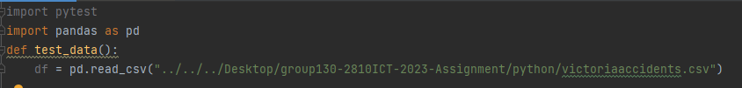

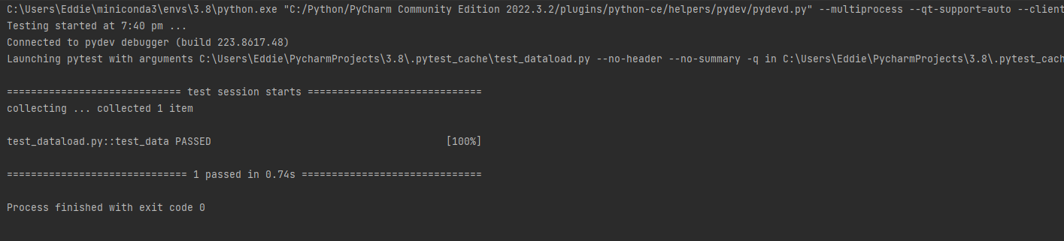

Test 1.2

Test 2.1

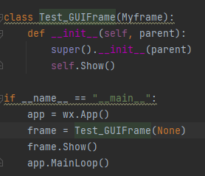

Test 2.2

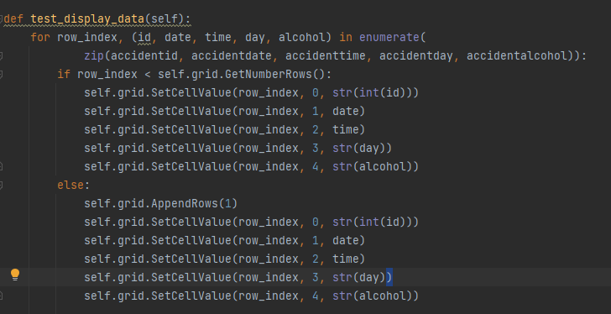

Test 2.3

Test 2.4

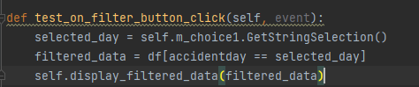

Test 2.5

Test 2.6

Test 2.7

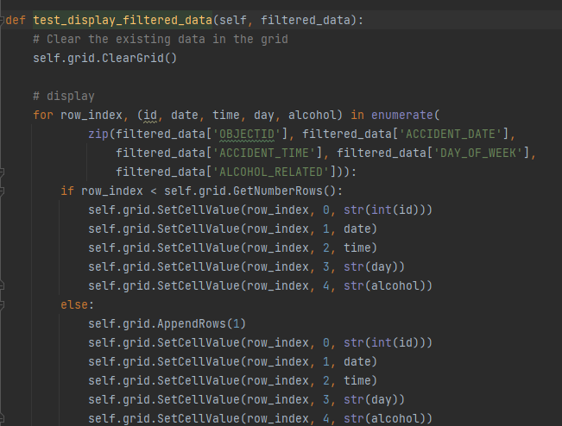

Test 2.8

# Coverage Report

A description of the coverage of your unit tests, including how you evaluated coverage (function, statement, branch, condition)

All the test units have been backed up with coverage to find any other errors with the code. Majority of the functions have been called successfully, however, there were issues with using the classes during the testing. Every coverage branch test was successful which shows that all the if statements are working currently in the program. The program does now have any Boolean sub-expressions, so the coverage could not detect any issues with the conditions.

# Requirements Acceptance Testing

| **Software  Requirement No** | **Test** | **Implemented (Full /Partial/ None)** | **Test Results (Pass/ Fail)** | **Comments (for partial implementation or failed test results)** |
| --- | --- | --- | --- | --- |
| 1 | For a user-selected period, display the information of all accidents that happened in the period. | Full | Pass |  |
| 2 | For a user-selected period, produce a chart to show the number of accidents in each hour of the day (on average). | None | Fail | The program does not produce a chart to show the number of accidents. |
| 3 | For a user-selected period, retrieve all accidents caused by an accident type that contains a keyword (user entered), e.g. collision, pedestrian. | None | Fail | The program cannot retrieve accidents that contain keywords |
| 4 | Allow the user to analyze the impact of alcohol in accidents – ie: trends over time, accident types involving alcohol, etc. | Full | Pass |  |
| 5 | One other ‘insight’ or analysis tool of your choice | Full | Pass |  |